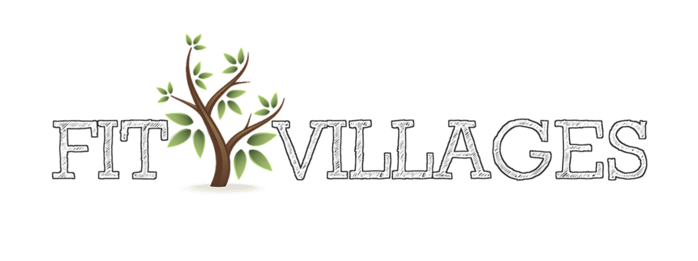

PILATES at Freckenham

Returning on Friday 13th January 11am -12pm

- Strengthen, tone & stretch yourself to a leaner you
- Strengthens lower back and core muscles
- Improves posture and balance
- Safe & progressive exercises

For more information and to book, please contact:
Hollie Wood; hollie.wood@suffolksport.com
Tel: 07900 138849

