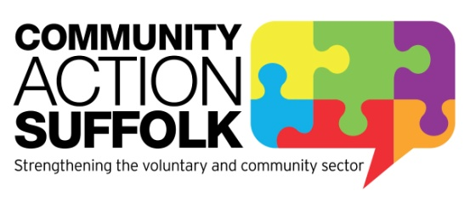

PRESS RELEASE: Released 23 November 2015
Save time and money: Buy your heating oil through a community bulk buying scheme
If you are one of 50,000 households in Suffolk which is off the mains gas network, Community Action Suffolk (CAS) could be saving you money on your heating bill.
CAS runs a community buying scheme which has purchased over 1.6 million litres of oil in the last year, giving households an average annual saving of £74 and higher volume users, such as community groups and rural businesses, a saving of £181.
The scheme’s members have made a collective saving of over £60,000 in the last twelve months as heating oil is purchased in bulk. Deliveries are planned to provide an environmental benefit, with one oil tanker making a single trip to several customers in a village, instead of making numerous trips to the same area. The tanker’s fuel consumption is also reduced and so is the heavy traffic through the village.
Natalie Lomas, Resources Officer at CAS, said:
“Membership to Community Buying at CAS is open to all; we aim to reduce the price customers pay for their oil, whilst also removing the hassle and worry of phoning around different suppliers for quotes. Members simply like the consistently low prices that we get for them, and the hassle free process of the scheme.
We take orders from our members across the county and place bulk orders twice a month (with the exception of December). We can also organise individual orders for people who miss a bulk order deadline, or find that they are running short.
We aim to provide our members with the best possible customer service and members don’t need to be on the internet in order to benefit from the savings. Since the start of the scheme, the price our members have paid has been consistently lower than the average they would have paid independently.”
Customer service is something which members really appreciate from the scheme. Ms Hayward from Campsea Ashe, said:
“There have been two occasions recently when the scheme has come to my rescue. On one occasion I needed an emergency oil order and had oil delivered to me within two days. Most recently, I actually ran out of oil and sent an email that evening. I certainly did not expect to hear until the following morning but within an hour, I received a response to my email and was assured I would have an oil delivery arranged as quickly as possible. It is very rare nowadays to find people who will go out of their way to help and support. The scheme is professional and whilst being kind and understanding. I cannot sing the scheme’s praises highly enough.”
As well as heating oil, CAS can also supply members with Fuel Additive, Red Diesel, Gas Oil and LPG. Membership starts from just £20 per year and members have the option of placing orders via the website, by email, post or telephone.
To become a member or for more information visit www.communitybuying.org.uk or call 01473 345400 for a membership pack to be sent to you.

ENDS
Notes to editors
Community Buying at CAS
The bulk oil buying process is conducted through Community Buying at CAS Ltd, reg. no. 04794467, which is a subsidiary of Community Action Suffolk (CAS), a charity that offers help and support services to voluntary and community groups in Suffolk. We provide bespoke services and products that are relevant, accessible and designed to meet the needs and expectations of individuals and community groups. We make sure the voluntary and community sector has easy access to networks, information, tools and resources, so they can operate successfully.
Contact
Natalie Lomas, Resources Officer
oil@communitybuying.org.uk
01473 345400

Denise Wrobbel, Marketing Officer Support Services
denise.wrobbel@communityactionsuffolk.org.uk
01473 345372
Community Action Suffolk reception
01473 345400

Office for National Statistics data published on CSE (Centre for Sustainable Energy) website https://www.cse.org.uk/projects/view/1259#Heating_and_housing_census_data

