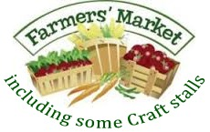
FRECKENHAM VILLAGE HALL

SATURDAY 27 JAN
10.00 TO 12 NOON
COME AND SEE WHAT WE HAVE ON OFFER
Refreshments – Drinks, Cakes, Bacon Rolls (bacon supplied by Eric Tenant Butchers, Newmarket)
Cheese, Olives & more from Barleycorn Deli; Meat; The Pie Kitchen; Seasonal Veg; Honey; Eggs; The Friendly Loaf Company; Preserves; WI; Herbs & Floral arrangements; Chocolate; Crafts – knitting; cards; needlework; bags; pinboards; jewellery; candles, diffusers & more to confirm. Connect with us on Facebook, Twitter, @FreckenhamVH
check www.freckenham.onesuffolk.net for updates.
Markets dates for early 2018 - 24 Feb, 24 March (note week early to avoid Easter weekend) etc.

