Monthly DC Report for Parish council meetings

October 2020

Good evening to you all my DC report for last month is : -

- The West Suffolk Council Leader is Cllr john Griffiths

- Main portfolio holders are
………………………………………………………………………………………

- Deputy Leader & Housing – Cllr Sara Midway-White
- Resources & Partnership - Cllr Sarah Broughton
- Governance - Cllr Carol Bull
- Regulatory - Cllr Andy Drummond
- Families & Communities - Cllr Robert Everitt
- Growth - Cllr Susan Glossop
- Leisure, Culture & Community Hubs - Cllr Jo Rayner
- Operations - Cllr Peter Stevens

- West Suffolk council like all Councils is now fully implicating the Governments Coronavirus 19 Policies.

- You can access the latest issue of the “Suffolk Resilience” data .
- Business support via www.westsuffolk.gov.uk/c19business or call 01284-763233
- A new focus group has been set up. The telephone number for those in genuine need of help is 0800-876-6926
- Revised Locality budget allocation have been issued to all District Councillors (your Parish Clerk has all the details)
- We are continuing to support the needs of rough sleepers in our area via www.streetlink.org.uk
- Brown Bin street collections are resuming week commencing 16th June in our area. Actual collection date can be checked online via
- https://westsuffolk-self.achieveservice.com/service/Waste_New_Round_Interim_Postcode_Lookup
just enter your postcode for your next collection dates.
- West Suffolk parks are now open – Brandon Country Park, Nowtown Park Bury and West Stow Country Park. Normal parking charges have now been reinstated

- Previously I have advised concerning Locality Budget Funding requests and specifically in support and Community Group Schemes set up as a direct result of the COVID 19. I have been able to support several local schemes and would request that any other Community Groups within your Parish Council area would like financial support for them to contact me directly via brian.harvey@westsuffolk.gov.uk

- The Manor Ward District Councillor’s Locality budget funding has so far supported the following : -

Barton Mill PC -: Good Neighbour Scheme: community support and engagement
Worlington PC -: Community Speed watch Laptop
Freckenham -: COVID19 Community Group Community phone tree
Worlington -: COVID19 Community Group Community phone tree
Joint funding supported by West Suffolk DC -: Family Support Project EPIC Dad Baby Packs and Sharing Parenting Family Resource Packs
Joint funding with SCC Cllr Busuttil - Worlington Cricket Club safety ropes
Joint funding with other West Suffolk DC -: Suffolk Accident Rescue Service purchase of equipment and Meds

Additional funding is still available, all requests must be made directly to myself by email please. brian.harvey@westsuffolk.gov.uk

- The West Suffolk Draft Local Plan “Issues and Options” document for Public Consultation has now been approved by Full Council on the 29th September 2020.
The formal consultation period will commence between Tuesday 13th October through until 22nd December 2020. I will update accordingly.

- “County Lines” drug issues and the impact upon our rural communities is being actively pursued by Suffolk Constabulary. This is a cross border operation resulting in several arrests and prosecutions being made.
Recent updates and presentations by Suffolk Police concerning the issues are being actively pursued by the Constabulary .

- The Sunnica Solar farm “Statuary Consultation Period” has now commenced and will be effective between :–
22nd September 2020 through until the 2nd December.

All Residents and Businesses within Zone 1 will now have received a copy of the “Consultation Booklet”.
Their web site for all information is at www.sunnica.co.uk /downloads
Due to the COVID19 lockdowns only virtual presentations are permissible.

The Sunnica webinars dates are now available via their web page at https://sunnica.co.uk/public-consultation/#webinars .

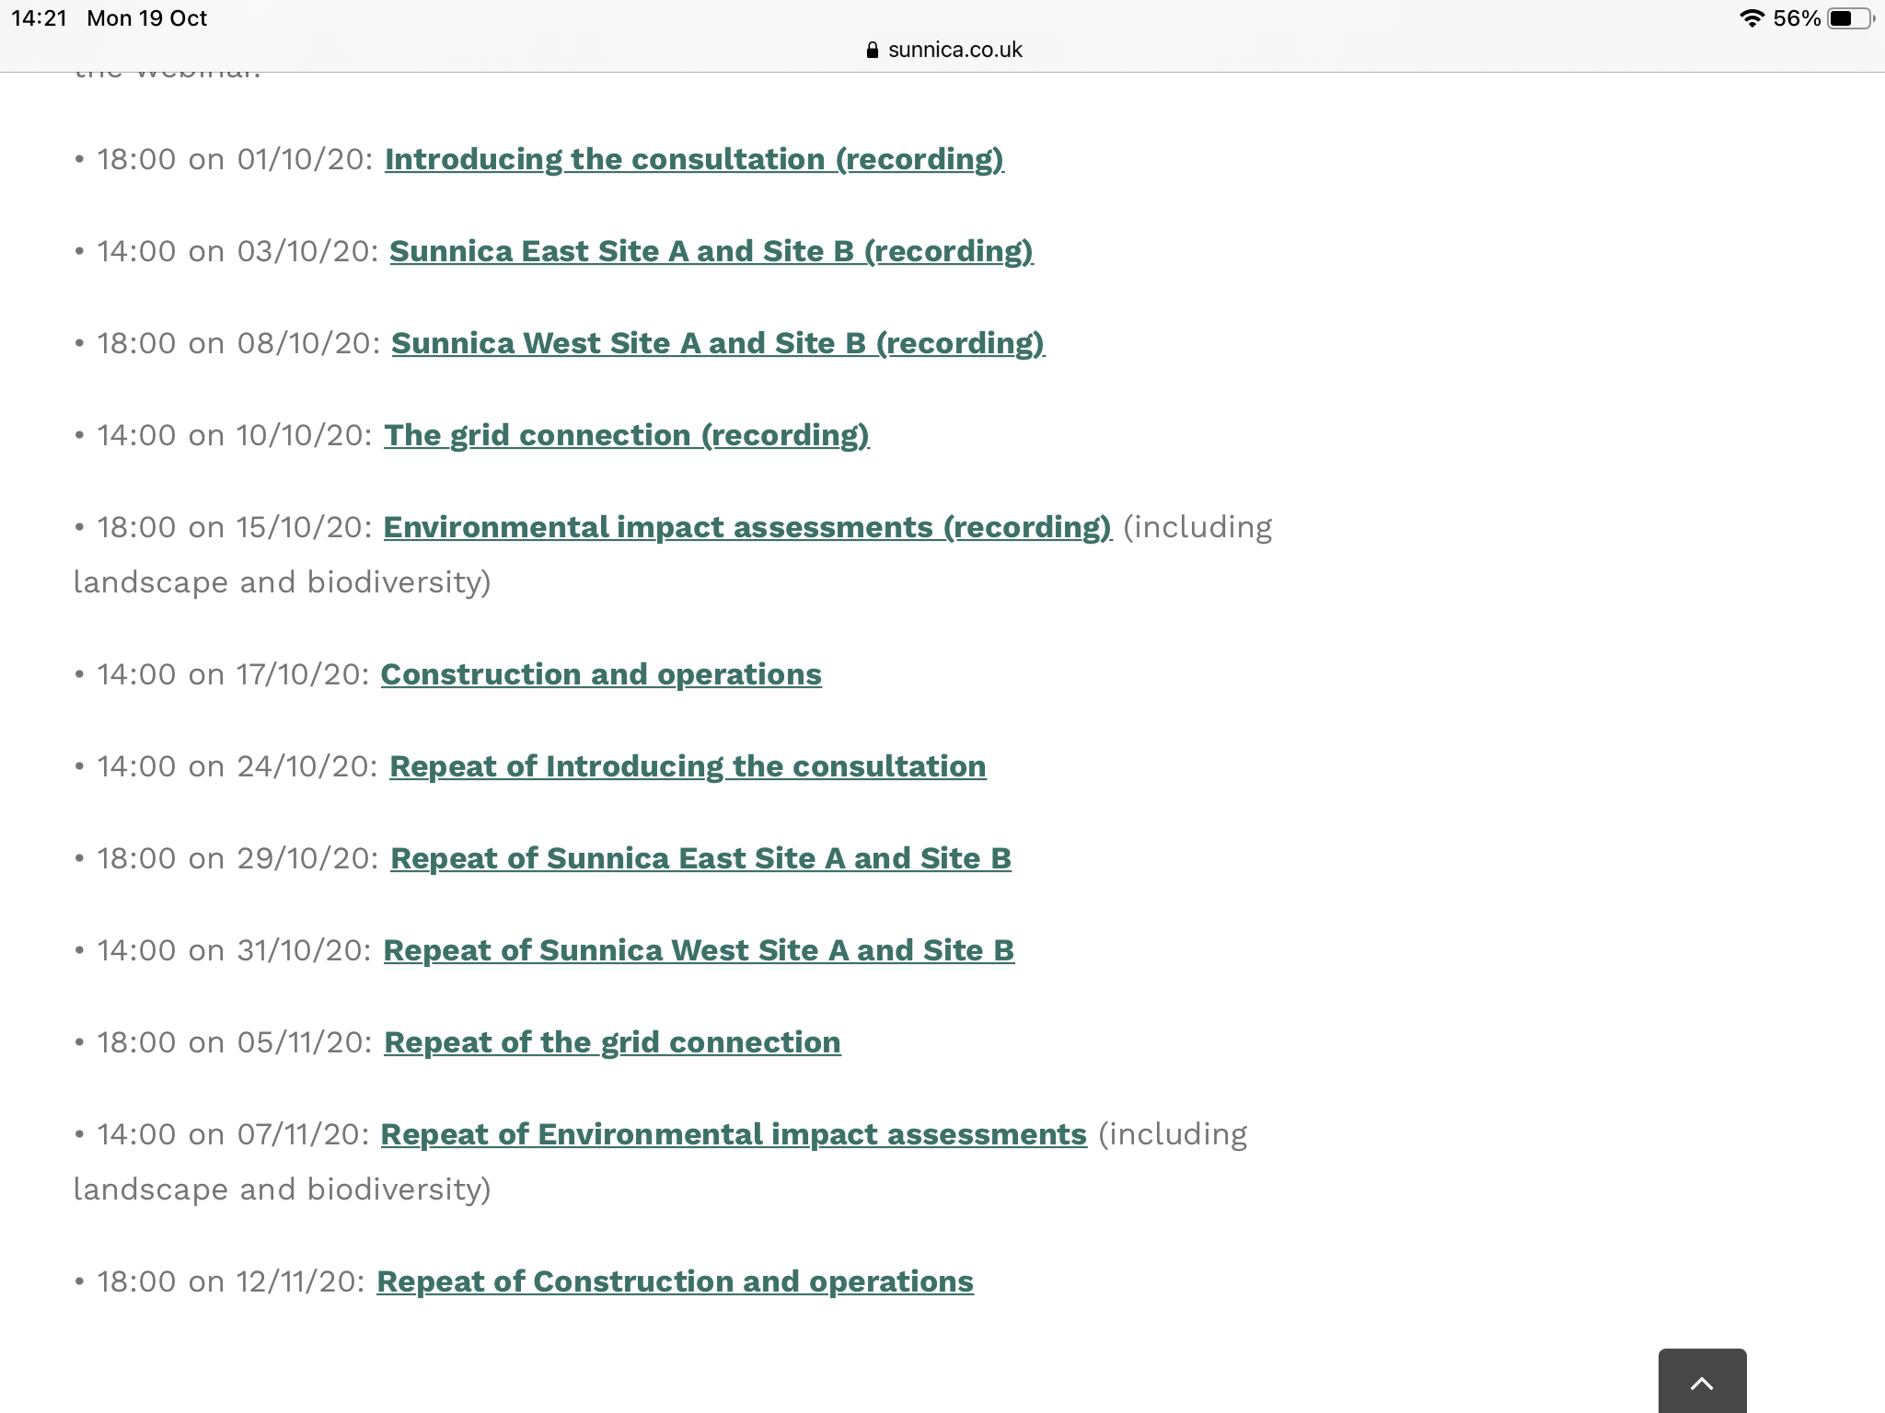

Please note that you must register to view these. This is done by clicking on the webinar you would like to join, you then will receive a personal link to the site.

Please be advised that only written feedback will be admissible and must be made via the - www.sunnica.co.uk web site.
Feedback can also be made via the Post or Emailed directly to Sunnica.

- Civil Parking Enforcement (CPE) effective from 6th April is now working well throughout West Suffolk District Council.

- West Suffolk Council are part of the Suffolk wide campaign to crack down on fly tipping with prosecutions taking place via the Court system accordingly.

If Residents are aware of fly tipping in their villages please contact Dominic Owner by email at dominic.owner@westsuffolk.gov.uk with a copy to myself please.

- West Suffolk Council has taken active steps to reduce the numbers of people rough sleeping in the West Suffolk Area.
This is a very difficult and challenging situation. We have received additional funding of £450K from the Government to assist in these cases.
If you see or suspect someone is rough sleeping please report this to – www.streetlink.org.uk or directly to our Team on 01282-7578178

- A date for your diaries, the next “Parish & Town Forum” which will be held virtually is planned for Wednesday 4th November 2020.
Full details and agenda to follow.

- The process for Planning application reviews has changed slightly . It is now very important if Residents or Parish Councils have any concern’s to ensure that these are raised with their Local Parish Council and the appropriate Planning Case officer with copies to myself please at :-

brian.harvey@westsuffolk.gov.uk or on my mobile – 07801-472461

This will ensure that these can then be fully briefed and reviewed at the “Appropriate Delegation Panel meeting”.

I’m happy to take any questions
Thank you
Brian

I’m also on Twitter @Brian4manorward

