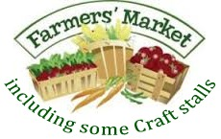
FRECKENHAM VILLAGE HALL
27th Apr, 25th May & 29th June

10.00 TO 12 NOON
Free Entry. Refreshments cakes, bacon rolls & more.
COME & SEE WHAT STALLS ARE THESE MAY INCLUDE

Plantation Farm Fruit & Veg; Buttercupps Baking or Serena Bakes; Meat from www.tfmbutchers.co.uk; Honey; Eggs; Pies; Pickles & Jams; Candles; wire jewellery; Cards; Knitted goods, fabric handiwork; bathing treats; chocolates; Quilting, Animal Artist, Wine, Branching Out with bird & bug boxes & more; Floral bouquets, bedding plants & plants, plus plants from local gardens if the weather has been kind!
Helpful if you can pre-order direct with stallholders via their websites & facebook pages.
Toilets available. Handsanitisers. The Golden Boar Inn is open from noon, check their facebook page or call 01638 723000 to see what’s on offer.
Connect with us on Facebook, @FreckenhamVH & Freckenham Community Group check website http://freckenham.suffolk.cloud for updates. The Farmers Market takes a break over July & August, coming back 28th September.

